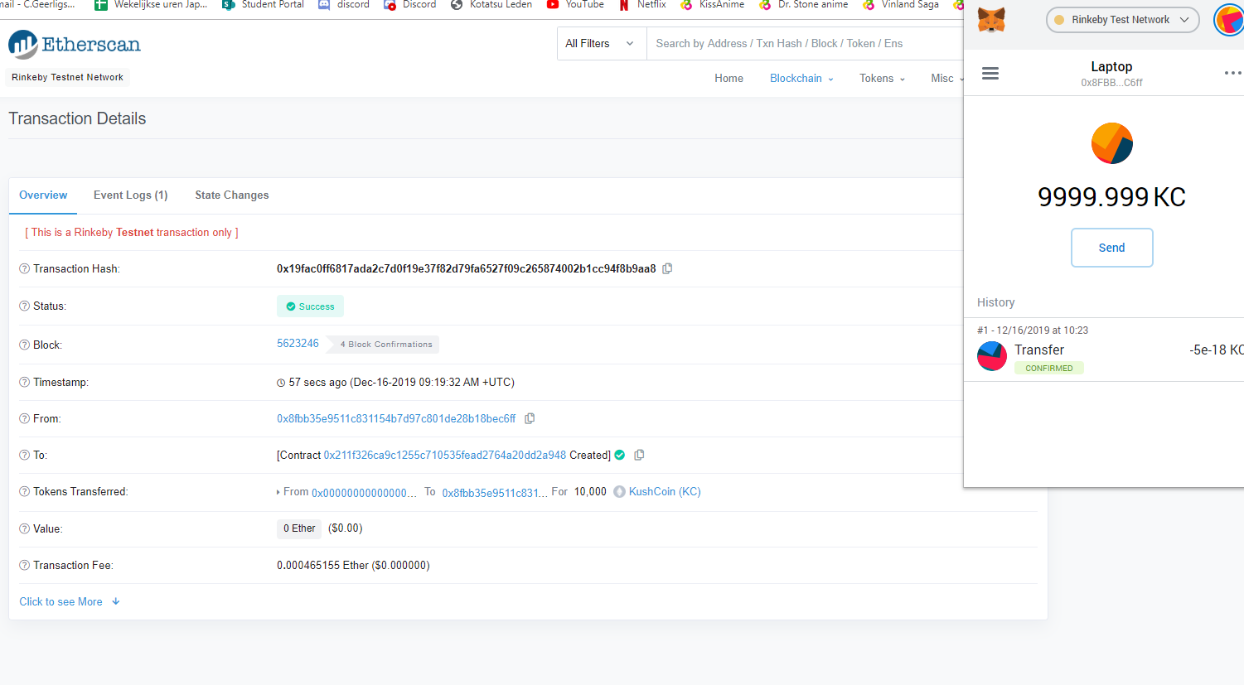

Prove of my fungible token on etherscan.

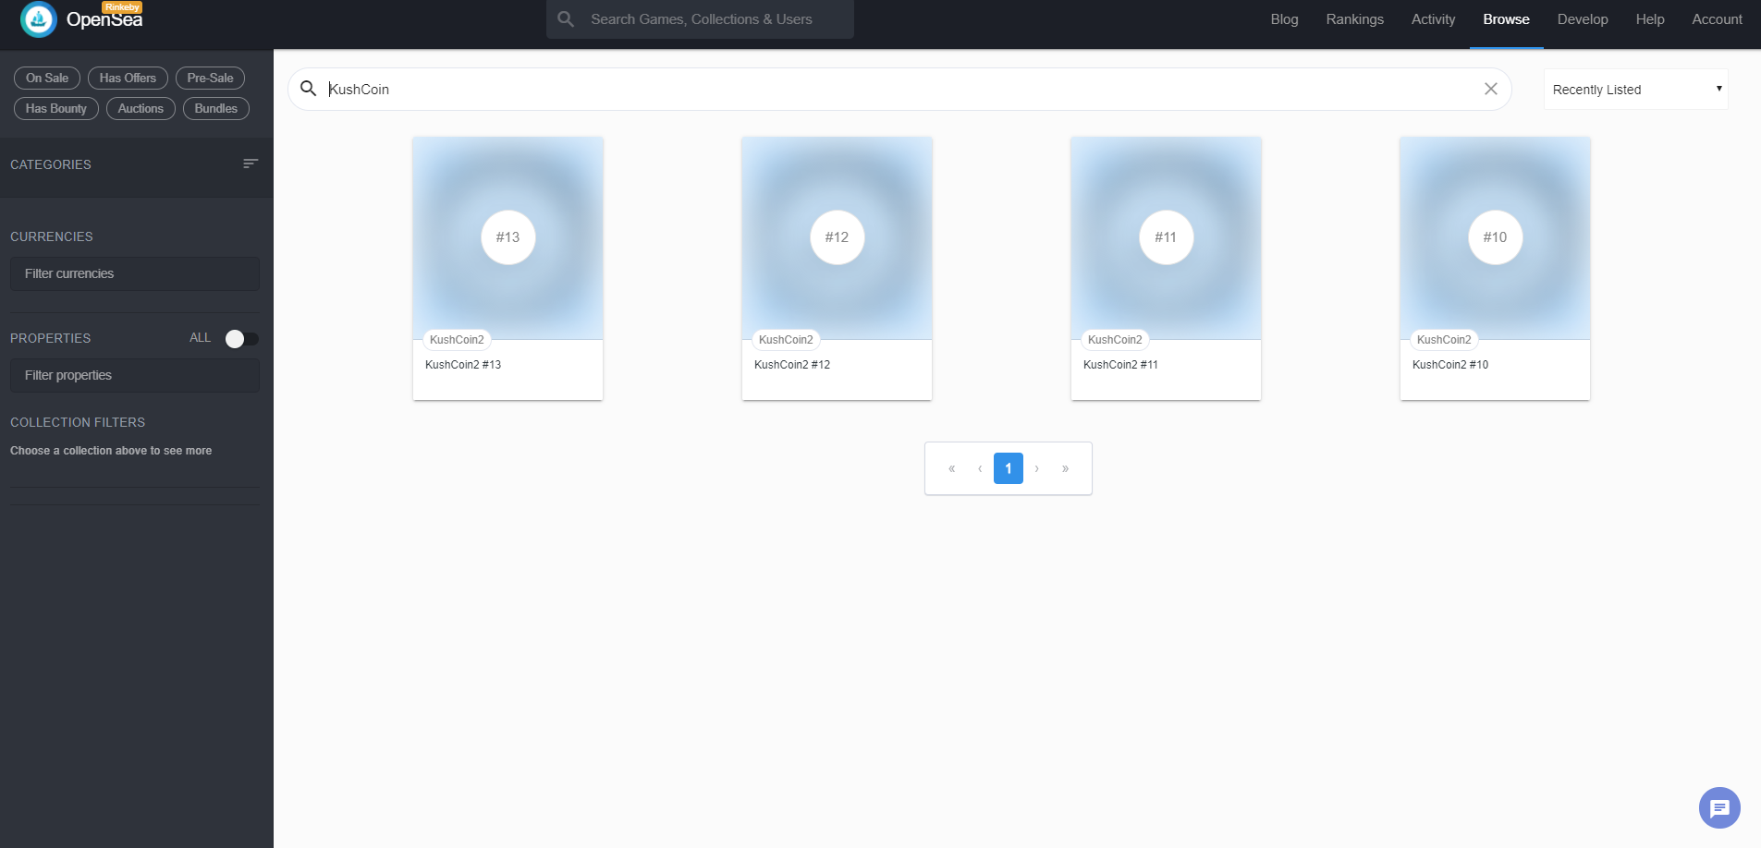

My non-fungible token on Opensea.

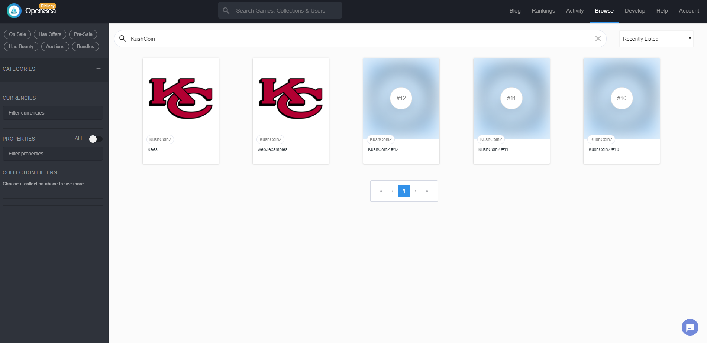

My non-fungible token + image on Opensea.